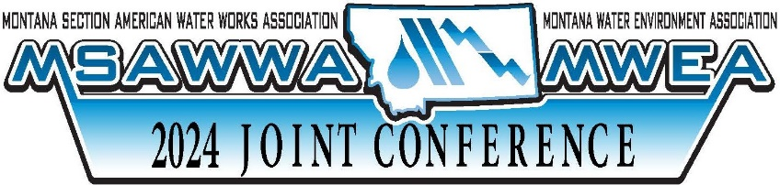

MSAWWA-MWEA JOINT CONFERENCE

- APRIL 24-25, 2024 – Missoula, MT
PRECONFERNCE (sponsored by MSAWWA)
- APRIL 23, 2024 – Missoula, MT

WHY SHOULD YOU ATTEND THE JOINT CONFERENCE?

VALUE OF JOINT CONFERENCE:
GENERAL TIPS
- Identify your organization’s benefits with specific needs and Conference sessions offered

- List issues that your organization may be facing where the conference may assist in finding solutions

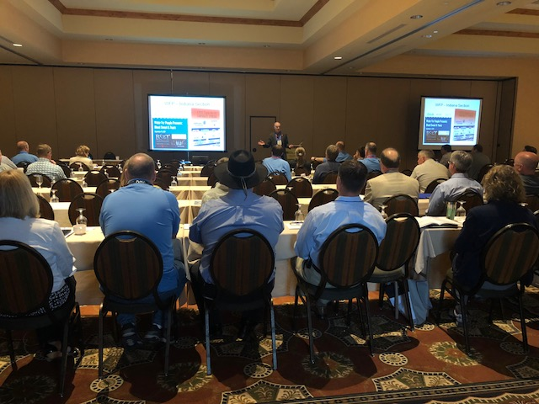

Powerful Networking Opportunities
- Utility Contacts
- Vendor Contacts
- Engineering Contacts
- Regulatory Contacts
Continuing Education Credits
- Educational experience
Obtain most or all required annual CEUs at one time with
maximum benefit
Solutions to Current Problems
- Solutions to regulatory, equipment and process issues
Finding Ways to do More with What We Already Have
- Meeting with colleagues to provide insights into how you can deliver better performance and/or service
New Technologies
- Explore industry trends and innovations introducing more cost-effective approaches to water and wastewater processes
Cross-Training
- While attending conferences it gives others in your organization opportunity to learn your job and take on more responsibility
Staff Presentations
- Share the Information gained from MSAWWA-MWEA Joint Conference
- Prepare and submit a written report to your manager of findings with short term and long-term action items
- Prepare and deliver a staff briefing of findings so that your organization can benefit from what you learn
- Assist others in learning how to effectively attend a similar conference and deliver the maximum benefit to your organization
JUSTIFICATIONS:

Justify the Expense
- Focus on the knowledge & information you will be bringing back to your team
- Calculate your expenses for attending the conference
  - Registration
  - Travel Costs
  - Lodging
  - Per Diem
  - Mileage Reimbursement

Details to Identify
FOR MORE INFORMATION VISIT: WWW.MONTANAWATER.ORG

- Session Content: Identify specific sessions that are relevant to your organizations’ work
- Vendor Contacts: Identify specific exhibitors & tools being showcased
- Highlight: The most relevant & innovative technologies & ideas around the state and beyond will be offered.
- Best Practices: Spotlight all the pertinent training sessions from which your group will immediately benefit
- Training: Emphasize relevant workshops designed to teach specific skills that will assist you and your team

