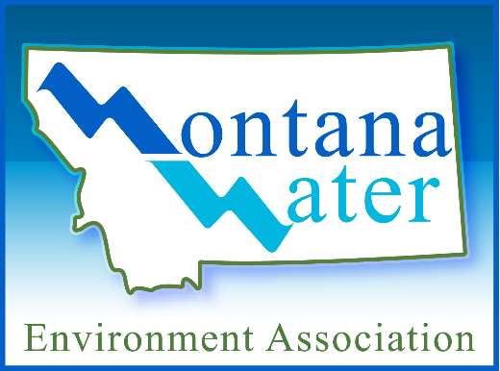

MWEA Award Nomination Form

- Name of Award:

- Nominee's Full Name or System Name:

Contact for System:

Title:

Mailing Address:

Phone Number:

- Eligibility/Justification: Please provide (in 250 words or less) a description of why the nominee is deserving of the listed award. (attach or insert verbiage to this form).

Submitted by:

Date:
Mailing Address:
Phone:
Submit To: Robin Matthews-Barnes
MSAWWA Exec. Secretary MWEA Exec. Director
PO Box 582
Seeley Lake, MT 59868
Info@montanawater.org

